program.py

1. **import** course
2. **import** student

5. """
6. @Description: 实验2
7. @Author: wyl2003
8. @Date: 2022-12-23 21:57:52
9. """
11. **def** main():
12. courses_list,students_list=[],[]
13. courses_file = open('courses.txt', 'r')
14. i = 0
15. **while** True:
16. line = courses_file.readline().rstrip()
17. **if** **not** line: #判断读到文件末尾
18. **break**
19. courses_list.append([])  #防止读取二维列表时报错
20. courses_list[i]=line.split(',')
21. courses_list[i].append(courses_file.readline().rstrip())
22. i += 1
23. courses_file.close()
25. students_file = open('students.txt', 'r')
26. i = 0
27. **while** True:
28. line = students_file.readline().rstrip()
29. **if** **not** line:
30. **break**
31. students_list.append([])
32. students_list[i]=line.split(',')
33. t = int(students_file.readline())
34. students_list[i].append(t)
35. temp = []
36. **for** count **in** range(t):
37. temp.append(students_file.readline().rstrip())
38. students_list[i].append(temp)
39. i += 1
40. students_file.close()
42. menu(courses_list,students_list)
44. **def** menu(courses_list,students_list):
45. **print**("-------------------------------------------------------------------------------------------\n\
46. The choice to maintain COURSEs information [add|remove|update|search|show]\n\
47. The choice to maintain STUDENTs information [insert|delete|modify|retrieve|display]\n\
48. The choice quit means to finish the program.[quit]\n\n\n")
49. tmp = input('Please enter choice:')
50. **if** tmp == 'add':
51. course.add(courses_list)
52. **elif** tmp == 'remove':
53. course.remove(courses_list,students_list)
54. **elif** tmp == 'update':
55. course.update(courses_list)
56. **elif** tmp == 'search':
57. course.search(courses_list)
58. **elif** tmp == 'show':
59. course.show(courses_list)
60. **elif** tmp == 'insert':
61. student.insert(students_list)
62. **elif** tmp == 'delete':
63. student.delete(students_list)
64. **elif** tmp == 'modify':
65. student.modify(courses_list,students_list)
66. **elif** tmp == 'retrieve':
67. student.retrieve(courses_list,students_list)
68. **elif** tmp == 'display':
69. student.display(courses_list,students_list)
70. **elif** tmp == 'quit':
71. my_quit(courses_list,students_list)
72. **else**:
73. **print**('Not a valid command - please try again.\n\n\n')
75. menu(courses_list,students_list)#回到菜单
77. **def** my_quit(courses_list,students_list):
79. temp_courses= open('new_course.txt', 'w')
80. s = ','
81. **for** i **in** range(len(courses_list)):
82. temp_courses.write(s.join(courses_list[i][0:5]))
83. temp_courses.write('\n')
84. temp_courses.write(courses_list[i][5])
85. temp_courses.write('\n')
87. temp_courses.close()
89. temp_students= open('new_students.txt', 'w')
90. k = '\n'
91. **for** i **in** range(len(students_list)):
92. temp_students.write(s.join(students_list[i][0:4]))
93. temp_students.write('\n')
94. temp_students.write(str(students_list[i][4]))
95. temp_students.write('\n')
96. temp_students.write(k.join(students_list[i][5]))
97. temp_students.write('\n')
99. **print**('\n\n-- Program Terminating --')
100. quit()
102. main()

course.py

1. #[add|remove|update|search|show]
2. #["Academic English I","31060101","3","Liang ZHU-GE","8-102","Two hours each week-day."]
3. **def** show(courses_list):
4. **print**('========================================\nAll Courses Information\n========================================')
5. **for** i **in** range(len(courses_list)):
6. **print**('----------------------------------------')
7. **print**('Course Name: '+ courses_list[i][0])
8. **print**('Course ID | Credits: '+ courses_list[i][1]+'|'+courses_list[i][2])
9. **print**('Instructor Name: '+ courses_list[i][3])
10. **print**('Address: '+ courses_list[i][4])
11. **print**('Description: '+ courses_list[i][5])
12. **print**('----------------------------------------\n========================================')
14. **def** search(courses_list):
15. tmp = input('Please enter course ID: ')
16. **for** i **in** range(len(courses_list)+1):  #+1 可以在未查找到项目时再次运行if语句 结束函数
17. **if** i == len(courses_list):
18. **print**('Course (ID='+ tmp +') is not found in the courses list.')
19. **return** 0 #结束该函数
20. **if** courses_list[i][1] == tmp:
21. **break**   #找到后暂停查找
22. **print**('Course Name: '+ courses_list[i][0])
23. **print**('Course ID | Credits: '+ courses_list[i][1]+'|'+courses_list[i][2])
24. **print**('Instructor Name: '+ courses_list[i][3])
25. **print**('Address: '+ courses_list[i][4])
26. **print**('Description: '+ courses_list[i][5])
28. **def** add(courses_list):
29. tmp = input('Please enter course ID: ')
30. t = len(courses_list)
31. **for** i **in** range(t):
32. **if** courses_list[i][1] == tmp:
33. **print**('Course (ID='+ tmp +') already exists in the courses list.')
34. **return** 0
35. courses_list.append([])
36. courses_list[t].append(input('Please input course name: '))
37. courses_list[t].append(tmp)
38. courses_list[t].append(input('Please enter course credits: '))
39. courses_list[t].append(input('Please enter course instructor: '))
40. courses_list[t].append(input('Please enter course address: '))
41. courses_list[t].append(input('Please enter course description: '))
42. **print**('Successfully added the Course (ID='+ tmp +') to the courses list.')
44. **def** update(courses_list):
45. tmp = input('Please enter course ID: ')
46. t = len(courses_list)
47. **for** i **in** range(t+1):
48. **if** i == t:
49. **print**('Course (ID='+ tmp +') is not found in the courses list.')
50. **return** 0 #结束该函数
51. **if** courses_list[i][1] == tmp:
52. **break**
53. **print**('Before updating, the course information:\n----------------------------------------')
54. **print**('Course Name: '+ courses_list[i][0])
55. **print**('Course ID | Credits: '+ courses_list[i][1]+'|'+courses_list[i][2])
56. **print**('Instructor Name: '+ courses_list[i][3])
57. **print**('Address: '+ courses_list[i][4])
58. **print**('Description: '+ courses_list[i][5])
59. **print**('----------------------------------------')
60. courses_list[i][0] = input('Please input course name: ')
61. courses_list[i][1] = tmp
62. courses_list[i][2] = input('Please enter course credits: ')
63. courses_list[i][3] = input('Please enter course instructor: ')
64. courses_list[i][4] = input('Please enter course address: ')
65. courses_list[i][5] = input('Please enter course description: ')
66. **print**('Successfully updated the Course (ID='+ tmp +') to the courses list.')
68. **def** remove(courses_list,students_list):
69. tmp = input('Please enter course ID: ')
70. **for** i **in** range(len(courses_list)+1):
71. **if** i == len(courses_list):
72. **print**('Course (ID='+ tmp +') is not found in the courses list.')
73. **return** 0 #结束该函数
74. **if** courses_list[i][1] == tmp:
75. **break**
76. **for** j **in** range(len(students_list)): #删除学生个人课表相关 课程删除后学生课表也要删
77. **for** k **in** students_list[j][5]:
78. **if** tmp == k:
79. students_list[j][5].remove(tmp)
80. students_list[j][4]-=1
81. **del** courses_list[i]
82. **print**('Successfully removed the Course (ID='+ tmp +') from the courses list.')

student.py

1. #[insert|delete|modify|retrieve|display]
2. #["WuKong SUN","1766060102","m","Computer Science and Technology",2, ["31060103","31060104"]]
3. **def** display(courses_list,students_list):
4. **print**('========================================\nAll Students Information\n========================================')
5. **for** i **in** range(len(students_list)):
6. **print**('----------------------------------------')
7. **print**('Student Name: '+students_list[i][0])
8. **print**('Student ID (Gender): '+students_list[i][1]+'('+students_list[i][2]+")")
9. **print**('Major: '+students_list[i][3])
10. count = students_list[i][4]
11. **print**('Selected Courses ('+ str(count) +') :')
12. **if** count != 0:
13. **for** id **in** students_list[i][5]: #打印课程
14. **for** j **in** range(len(courses_list)):
15. **if** courses_list[j][1] == id:
16. **break**
17. **print**('    '+ id +':'+courses_list[j][0])
18. **print**('----------------------------------------\n========================================')
20. **def**  retrieve(courses_list,students_list):
21. tmp = input('Please enter student ID: ')
22. **for** i **in** range(len(students_list)+1):  #同样也是为了返回错误并结束函数
23. **if** i == len(students_list):
24. **print**('Student (ID='+ tmp +') is not found in the students list.')
25. **return** 0 #结束该函数
26. **if** students_list[i][1] == tmp:
27. **break**
28. **print**('\n\nStudent Name: '+students_list[i][0])
29. **print**('Student ID (Gender): '+students_list[i][1]+'('+students_list[i][2]+")")
30. **print**('Major: '+students_list[i][3])
31. count = students_list[i][4]
32. **print**('Selected Courses ('+ str(count) +') :')
33. **if** count != 0:
34. **for** id **in** students_list[i][5]:
35. **for** j **in** range(len(courses_list)):
36. **if** courses_list[j][1] == id:
37. **break**
38. **print**('    '+ id +':'+courses_list[j][0])
40. **def** insert(students_list):
41. tmp = input('Please enter student ID: ')
42. t = len(students_list)
43. **for** i **in** range(t):
44. **if** students_list[i][1] == tmp:
45. **print**('Course (ID='+ tmp +') already exists in the courses list.')
46. **return** 0
47. students_list.append([])
48. students_list[t].append(input('Please enter student name: '))
49. students_list[t].append(tmp)
50. gender = ''
51. **while** gender != 'f' **and** gender!= 'm':  #只可以输入m/f
52. gender = input('Please enter student gender(m/f): ')
53. students_list[t].append(gender)
54. students_list[t].append(input('Please enter student major:'))
55. students_list[t].append(0)
56. students_list[t].append([])
57. **print**('Successfully inserted the Student (ID='+ tmp +') into the students list.')
59. **def** modify(courses_list,students_list):
60. tmp = input('Please enter student ID: ')
61. t = len(students_list)
62. **for** i **in** range(t+1):
63. **if** i == t:
64. **print**('Student (ID='+ tmp +') is not found in the student list.')
65. **return** 0 #结束该函数
66. **if** students_list[i][1] == tmp:
67. **break**
68. mod=input('Modify student (ID='+ tmp +') [major|enroll|drop]: ')  #选择相关模式
69. **if** mod == 'major':
70. students_list[i][3] = input('Please enter student major: ')
71. **print**('Modified the major of Student (ID='+ tmp +').')
72. **print**('----------------------------------------\n\n')
73. **print**('\n\nStudent Name: '+students_list[i][0])
74. **print**('Student ID (Gender): '+students_list[i][1]+'('+students_list[i][2]+")")
75. **print**('Major: '+students_list[i][3])
76. count = students_list[i][4]
77. **print**('Selected Courses ('+ str(count) +') :')
78. **if** count != 0:
79. **for** id **in** students_list[i][5]:
80. **for** j **in** range(courses_list):
81. **if** courses_list[j][1] == id:
82. **break**
83. **print**('    '+ id +':'+courses_list[j][0])
85. **elif** mod == 'enroll':
86. tmp_course = input('Please enter ID of course to be enrolled in: ')
87. **for** k **in** students_list[i][5]: #个人课表里有没有
88. **if** k == tmp_course:
89. **print**('Course (ID='+ tmp_course +') is already in the enrolled courses list.')
90. **return** 0 #结束该函数
91. **for** j **in** range(len(courses_list)+1): #找整个课表里有没有
92. **if** j == len(courses_list):
93. **print**('Course (ID='+ tmp_course +') is not found in the courses list.')
94. **return** 0 #结束该函数
95. **if** courses_list[j][1] == tmp_course:
96. **break**
97. students_list[i][4]+=1
98. students_list[i][5].append(tmp_course)
99. **print**('Modified the information of Student (ID='+ tmp +').')
100. **print**('----------------------------------------\n\n')
101. **print**('\n\nStudent Name: '+students_list[i][0])
102. **print**('Student ID (Gender): '+students_list[i][1]+'('+students_list[i][2]+")")
103. **print**('Major: '+students_list[i][3])
104. count = students_list[i][4]
105. **print**('Selected Courses ('+ str(count) +') :')
106. **if** count != 0:  #打印学生选课
107. **for** id **in** students_list[i][5]:
108. **for** j **in** range(len(courses_list)):
109. **if** courses_list[j][1] == id:
110. **break**
111. **print**('    '+ id +':'+courses_list[j][0])
113. **elif** mod =='drop':
114. tmp_course = input('Please enter ID of course to be dropped: ')
115. **for** j **in** range(len(students_list[i][5])+1): #找选课表里有没有
116. **if** j == len(students_list[i][5]):
117. **print**('Course (ID='+ tmp_course +') is not found in the courses list.')
118. **return** 0 #结束该函数
119. **if** students_list[i][5][j] == tmp_course:
120. **break**
121. **del** students_list[i][5][j]
122. students_list[i][4]-=1
123. **print**('Modified the information of Student (ID='+ tmp +').')
124. **print**('----------------------------------------')
125. **print**('\n\nStudent Name: '+students_list[i][0])
126. **print**('Student ID (Gender): '+students_list[i][1]+'('+students_list[i][2]+")")
127. **print**('Major: '+students_list[i][3])
128. count = students_list[i][4]
129. **print**('Selected Courses ('+ str(count) +') :')
130. **if** count != 0:
131. **for** id **in** students_list[i][5]:
132. **for** j **in** range(len(courses_list)):
133. **if** courses_list[j][1] == id:
134. **break**
135. **print**('    '+ id +':'+courses_list[j][0])
137. **else**:
138. **print**('Not a valid command - returning to main menu.')
140. **def** delete(students_list):
141. tmp = input('Please enter student ID: ')
142. **for** i **in** range(len(students_list)+1):
143. **if** i == len(students_list):
144. **print**('Student (ID='+ tmp +') is not found in the students list.')
145. **return** 0 #结束该函数
146. **if** students_list[i][1] == tmp:
147. **break**
148. **del** students_list[i]
149. **print**('Successfully removed the Course (ID='+ tmp +') from the courses list.')

运行示例1

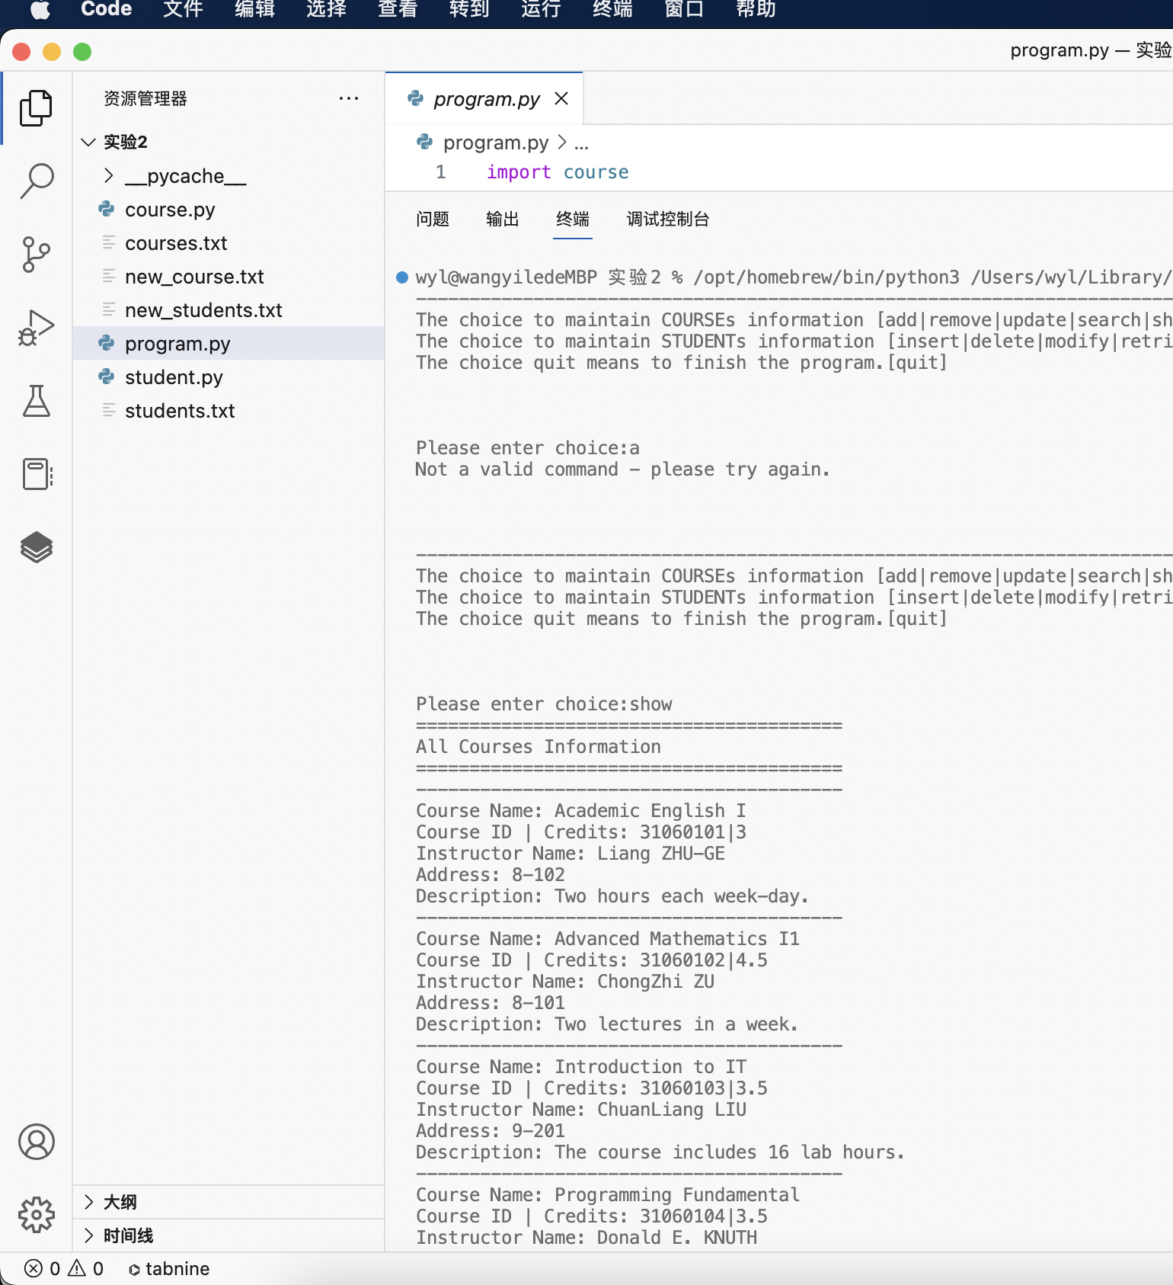

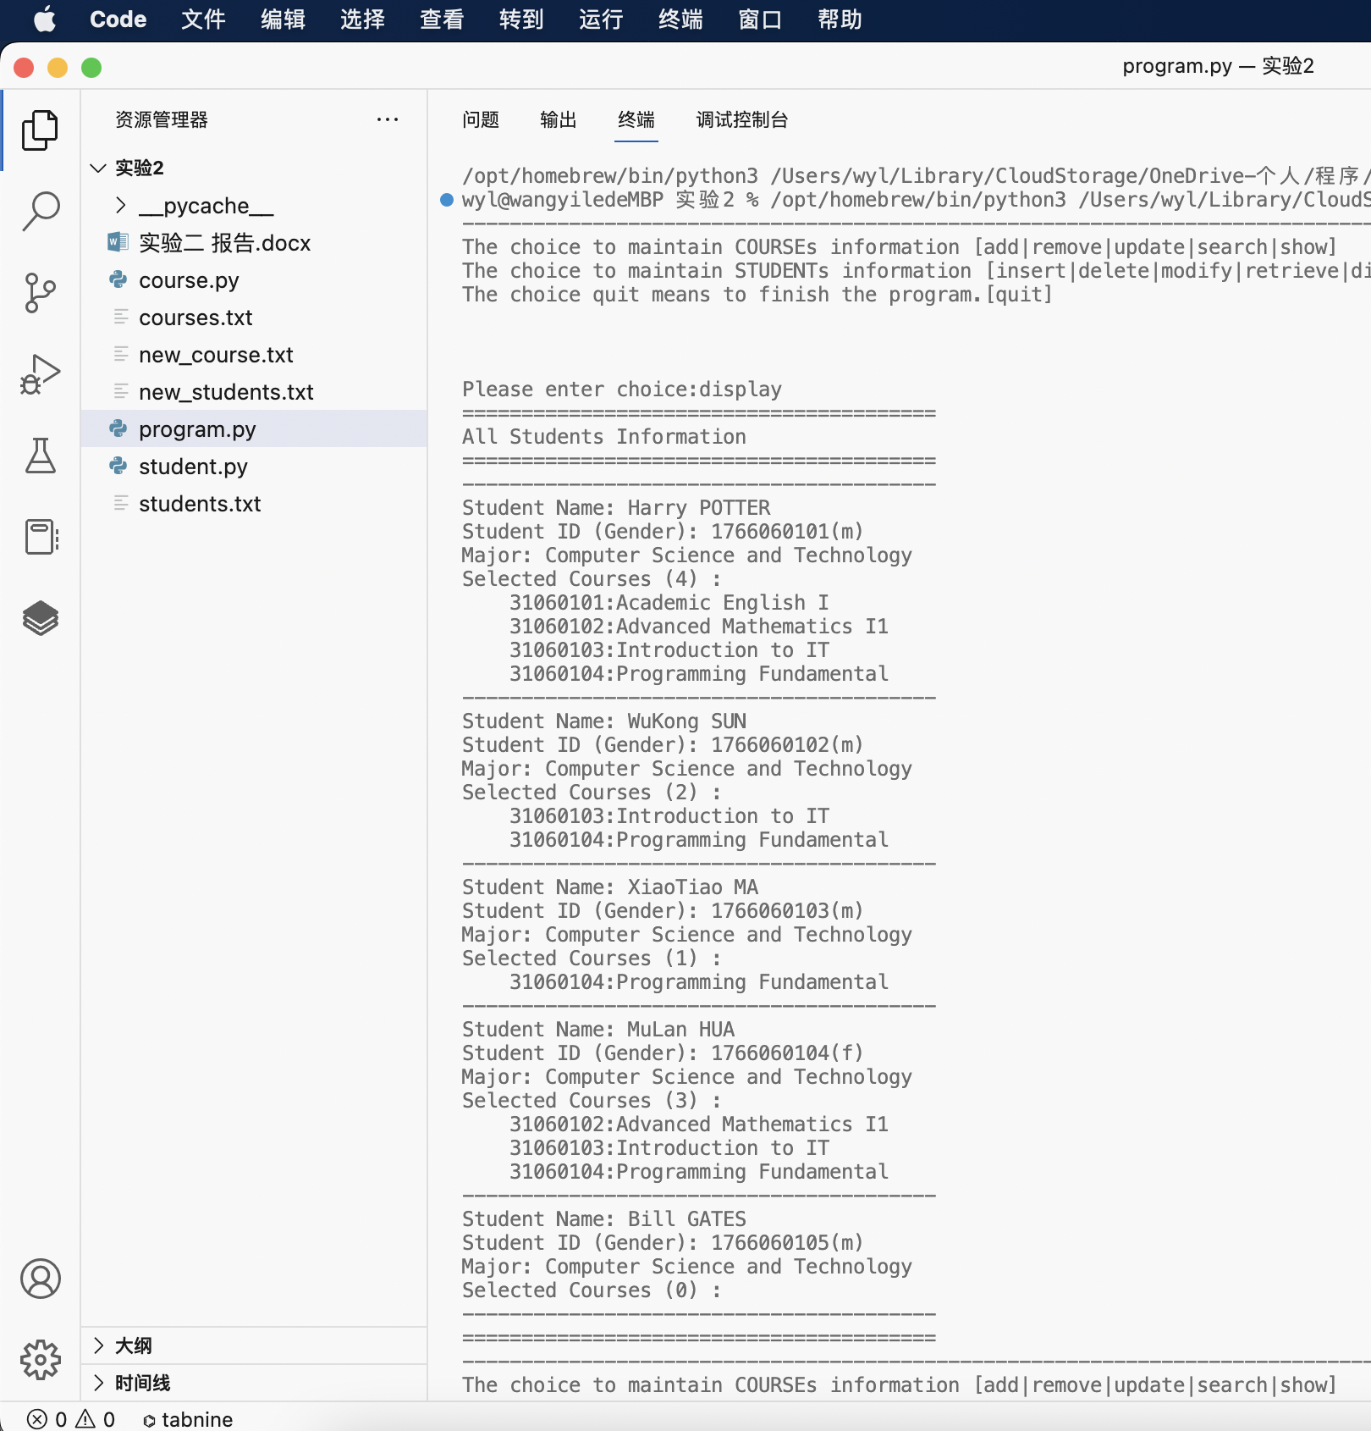

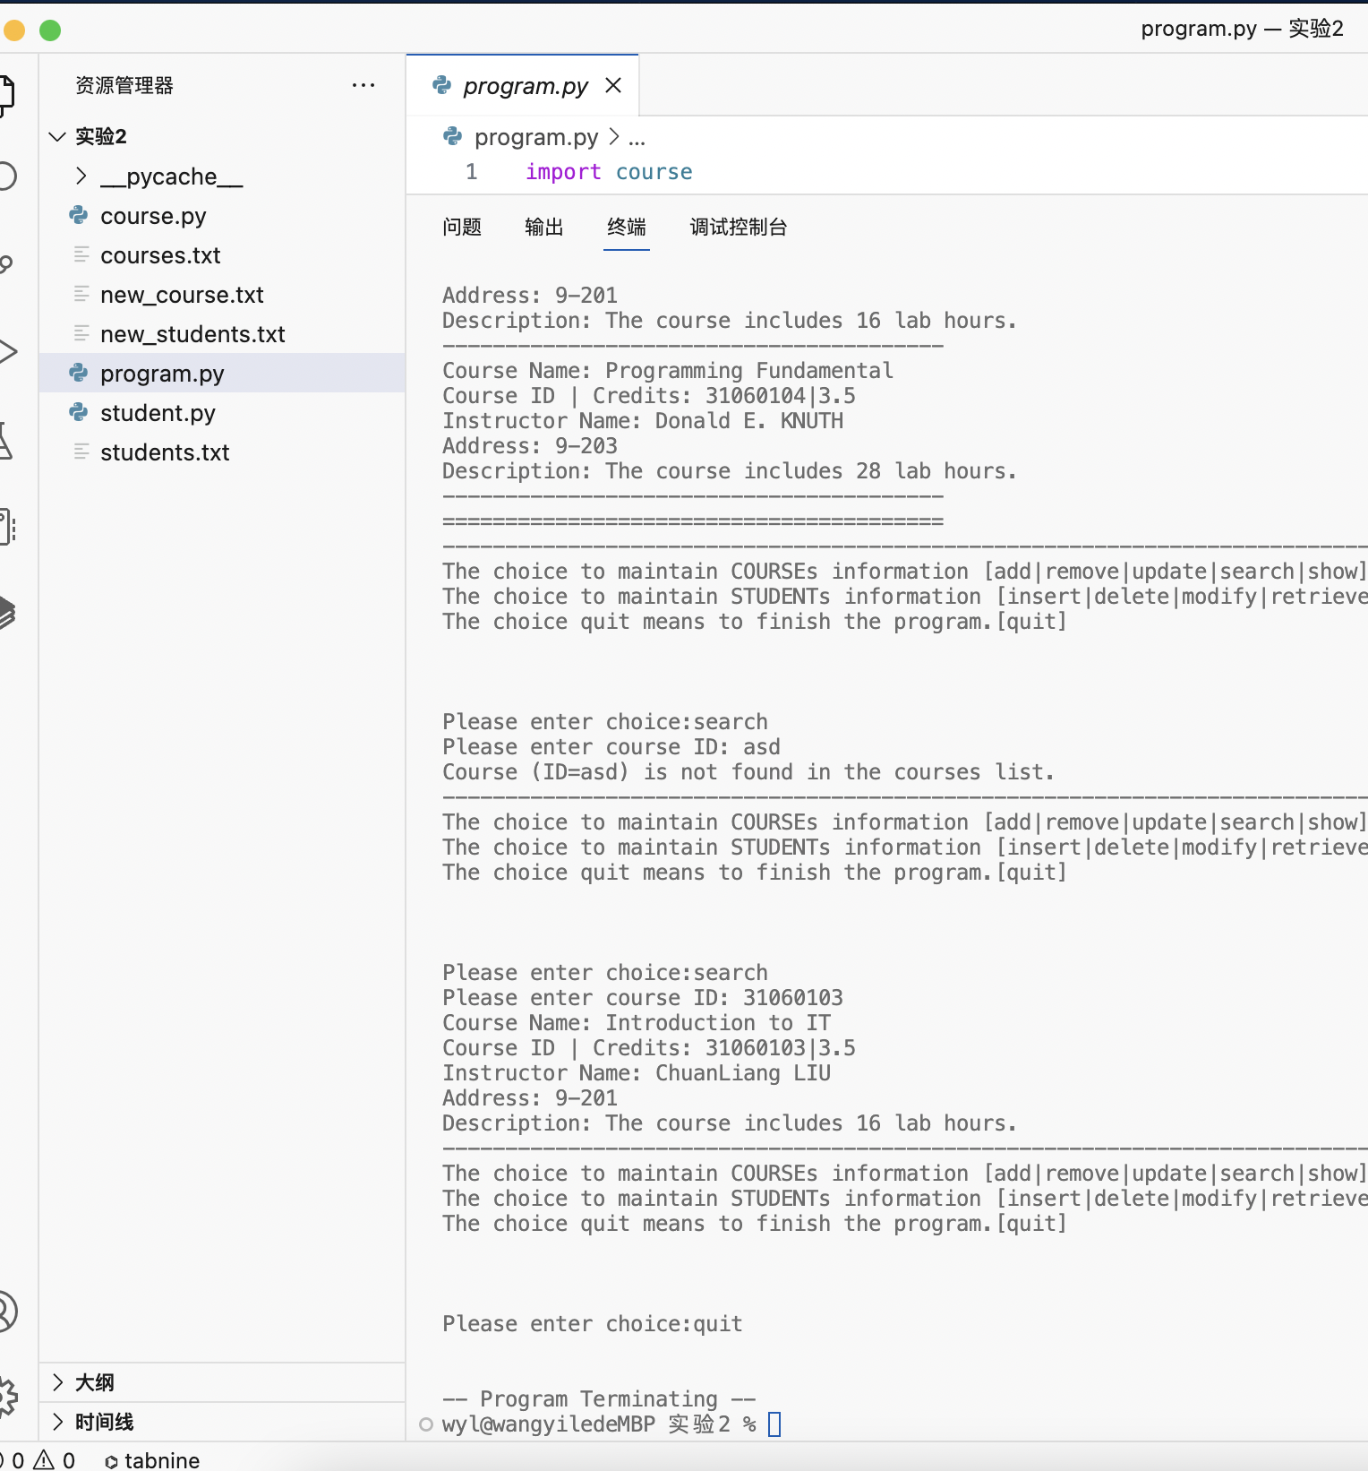

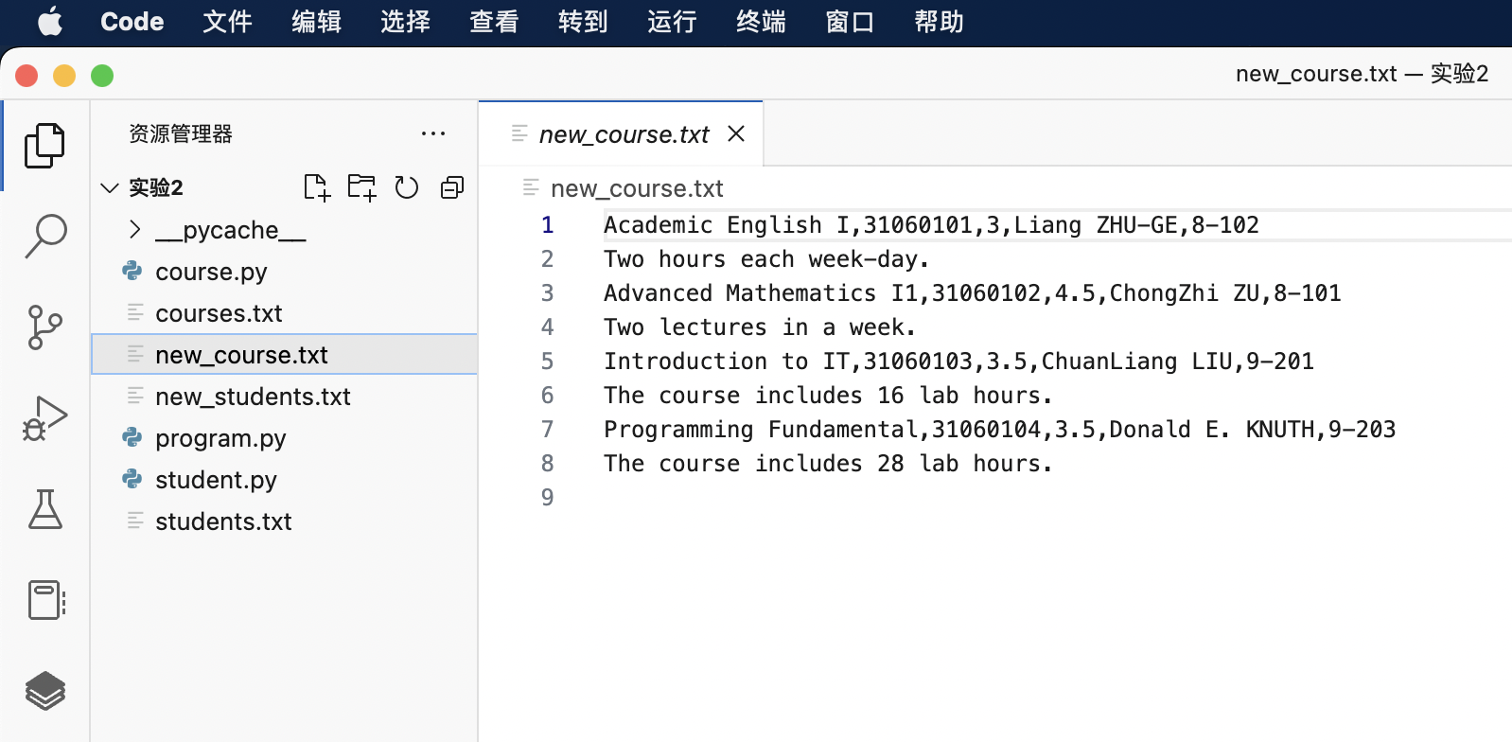

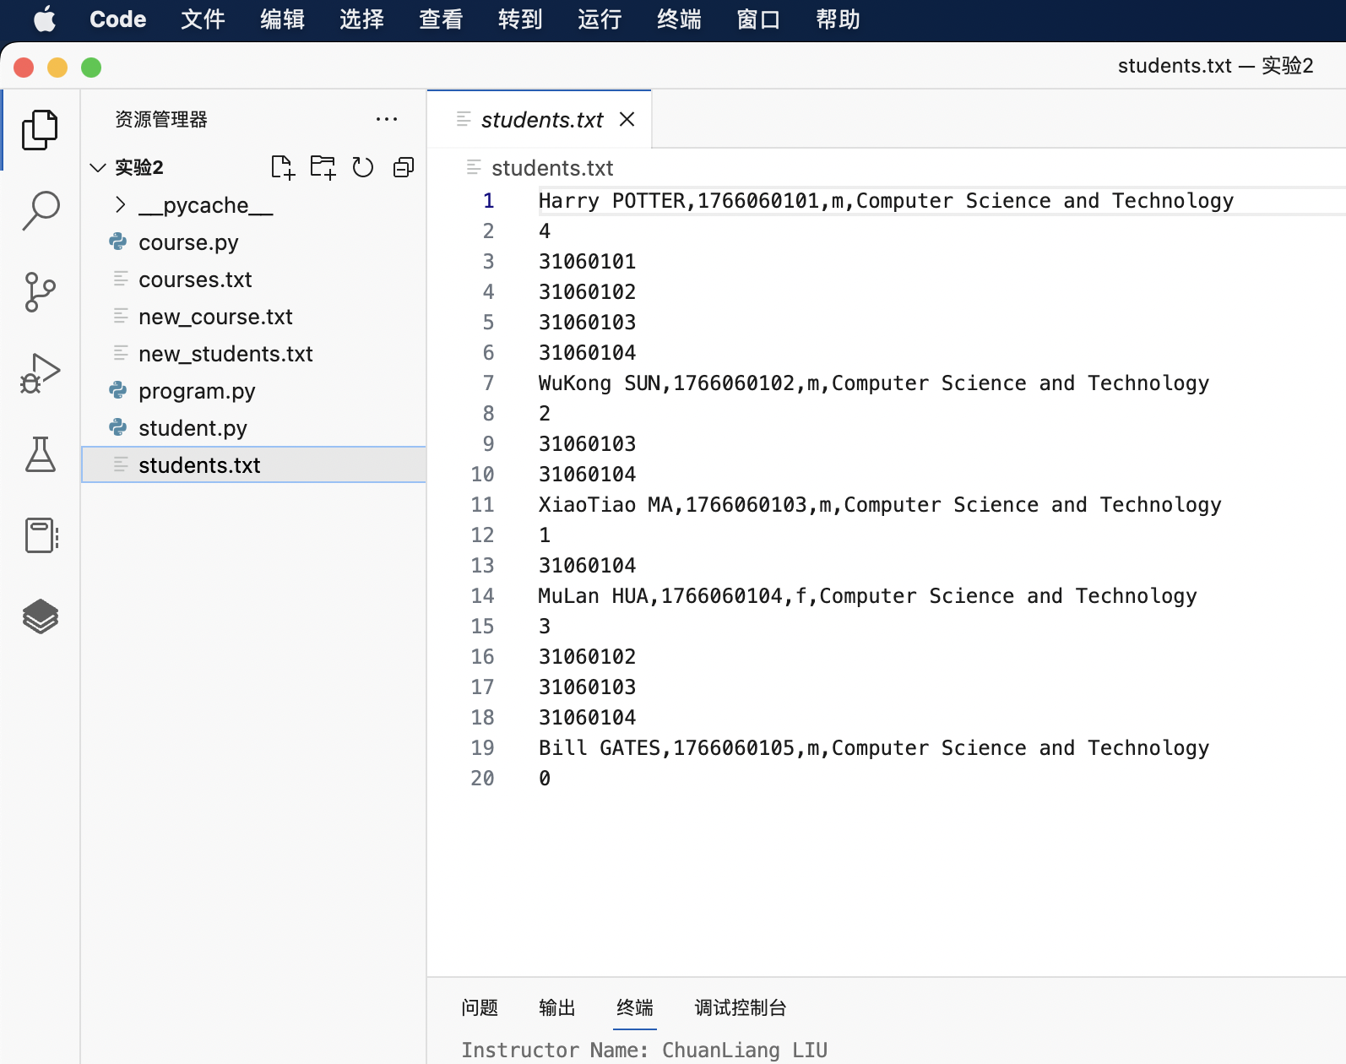

运行示例2

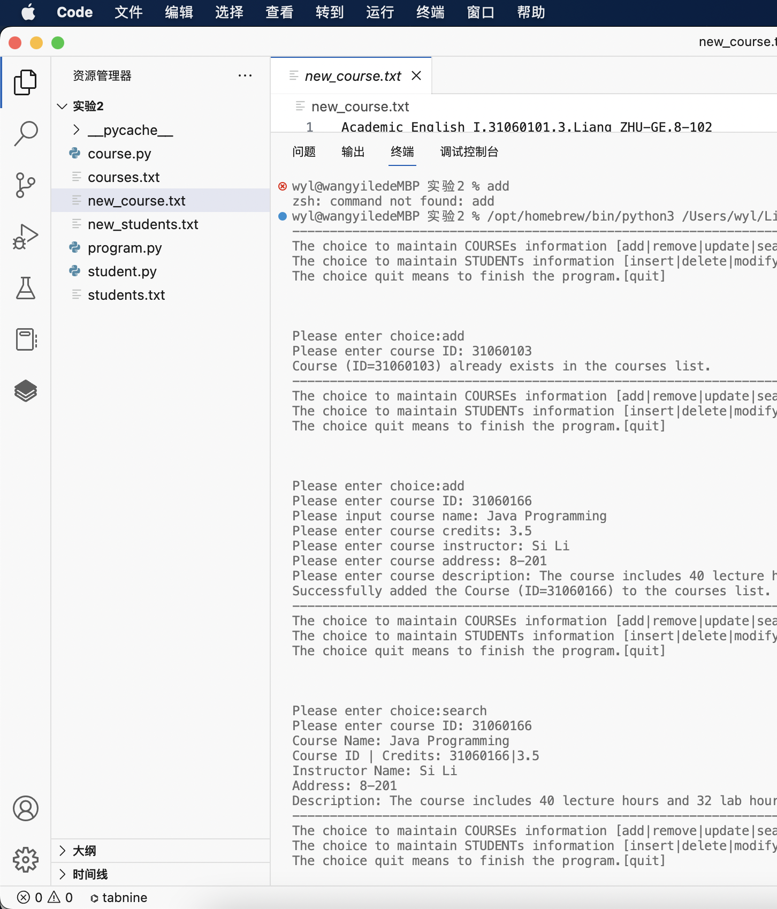

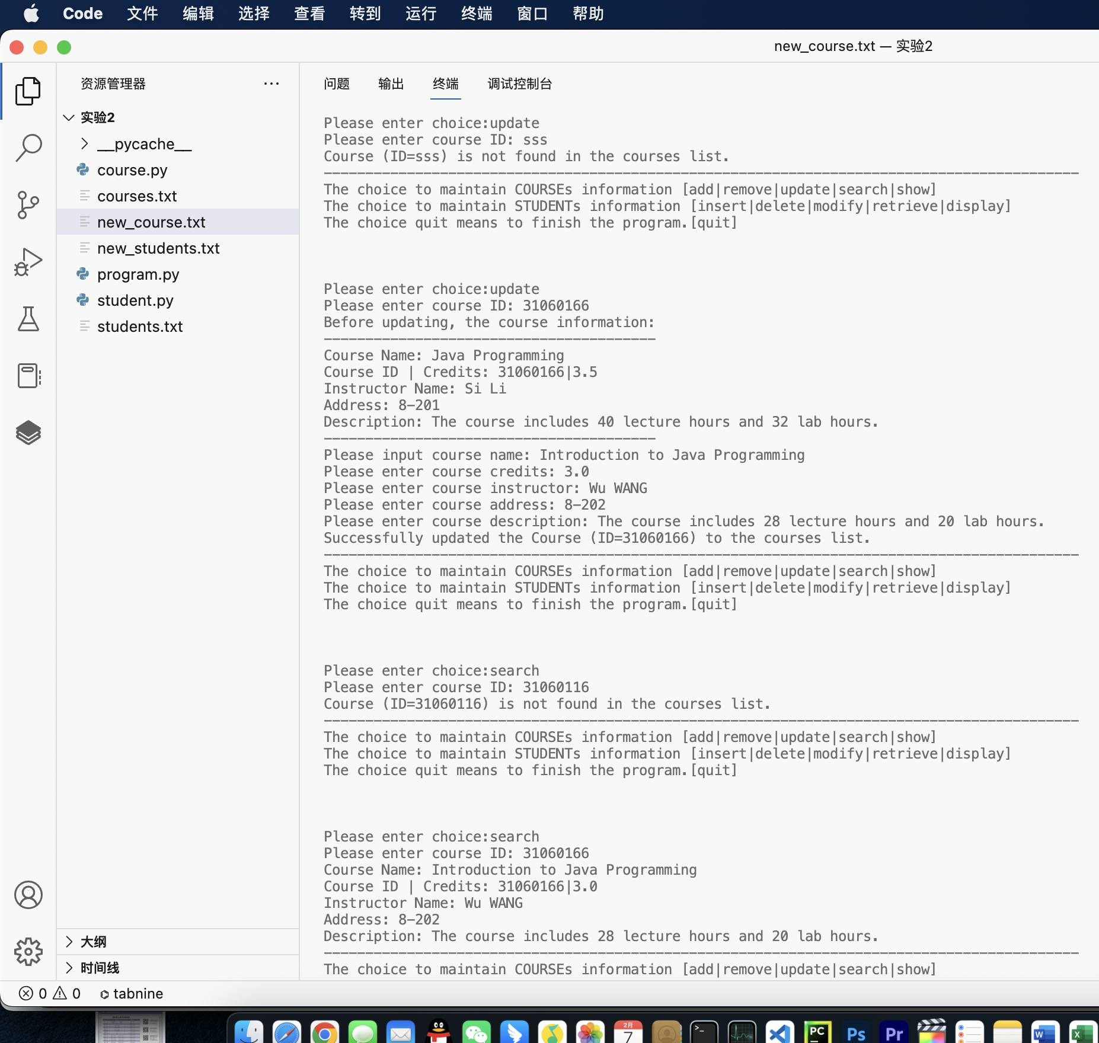

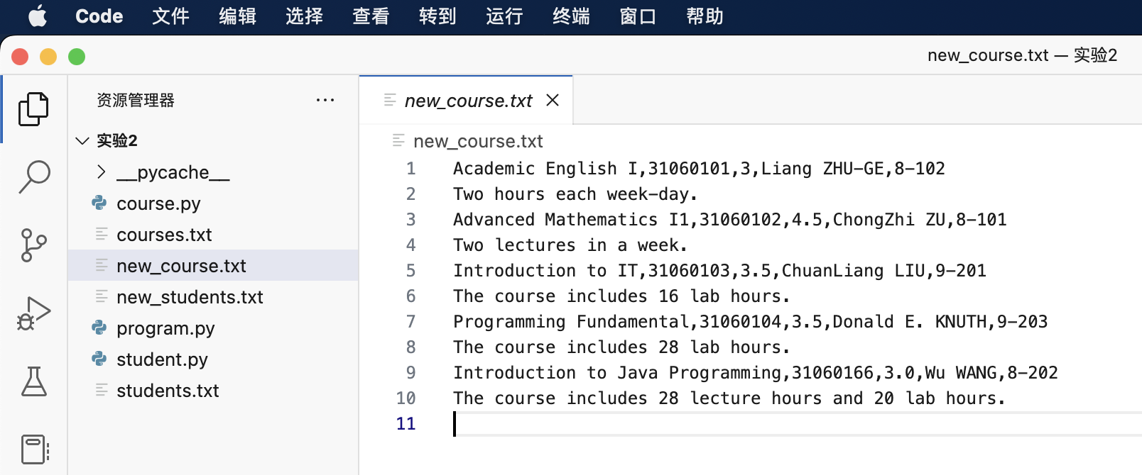

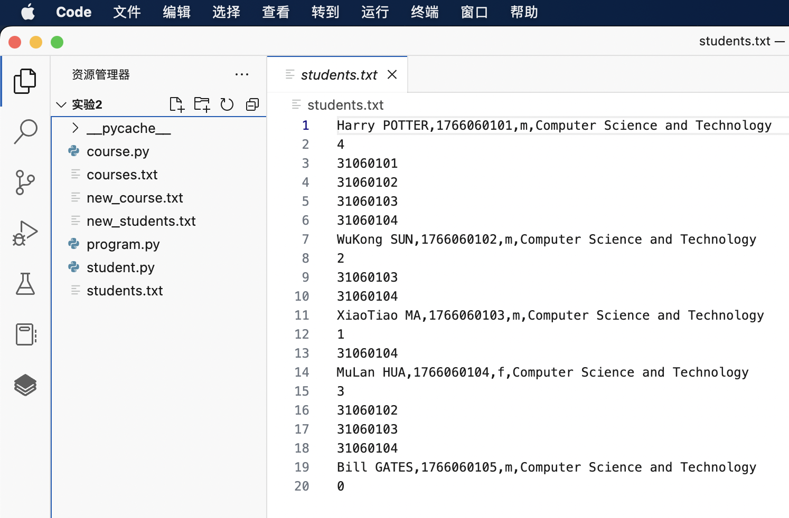

运行示例3

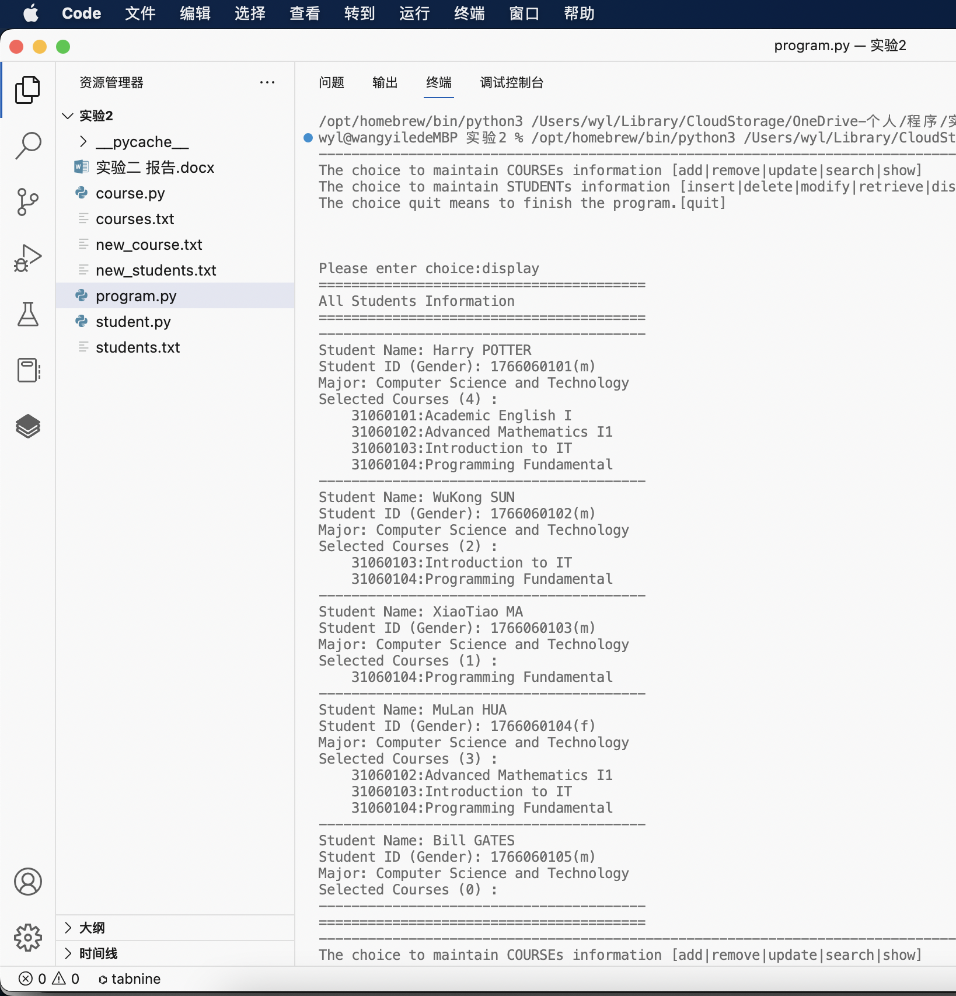

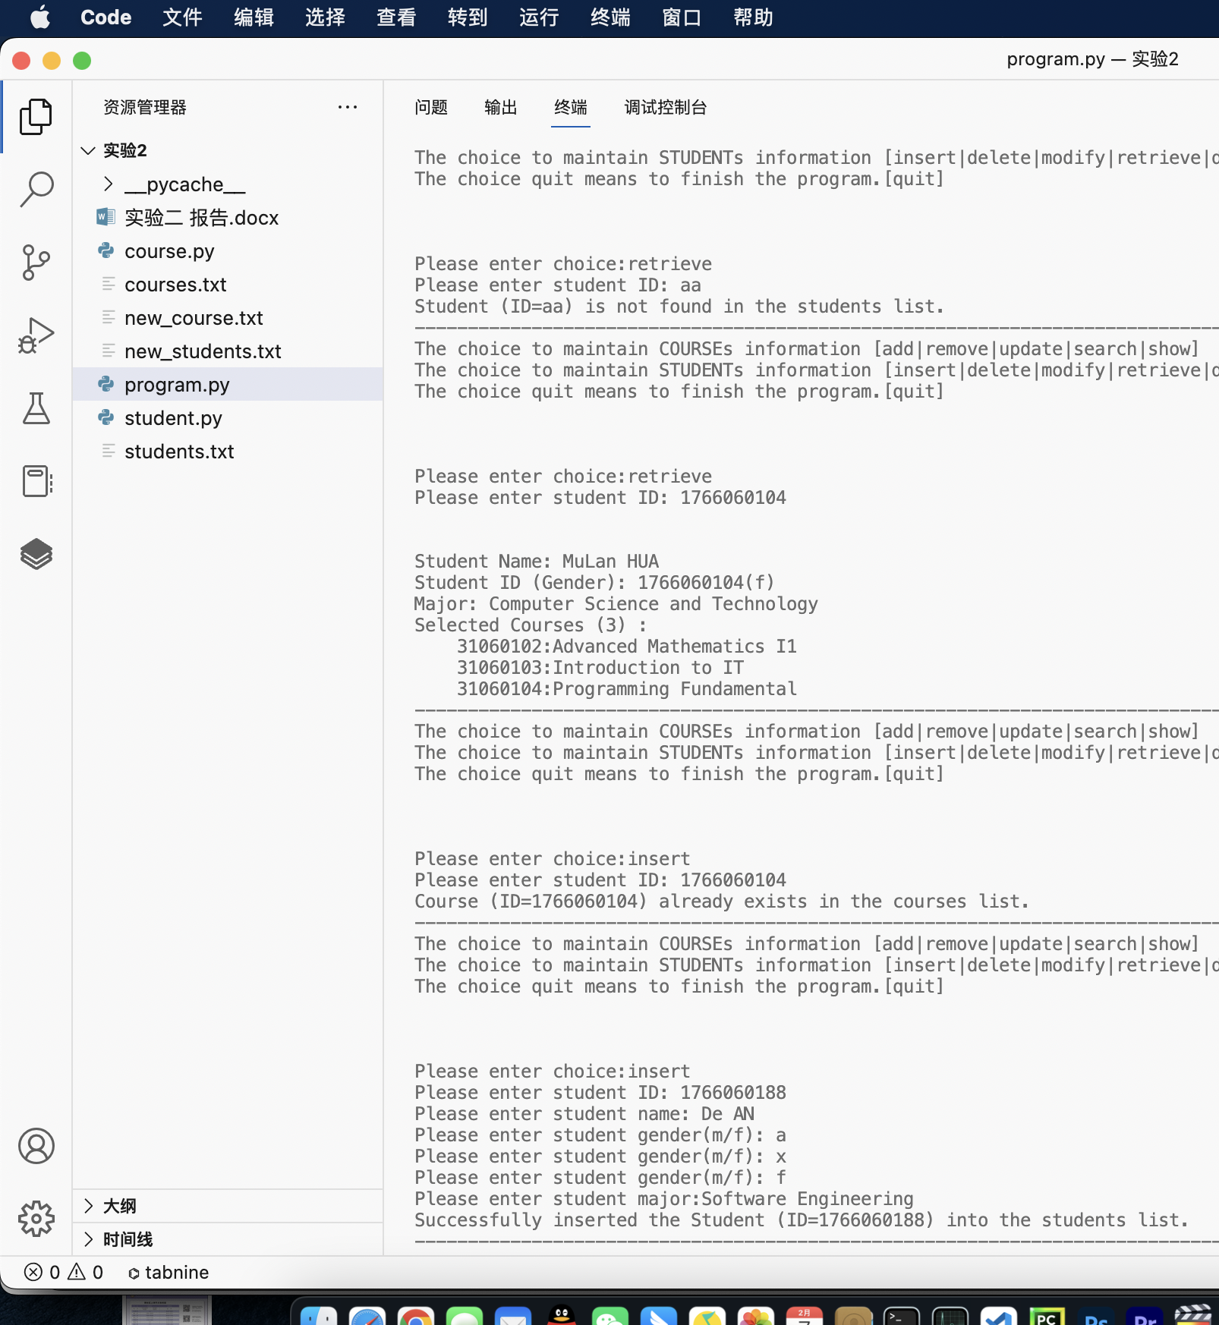

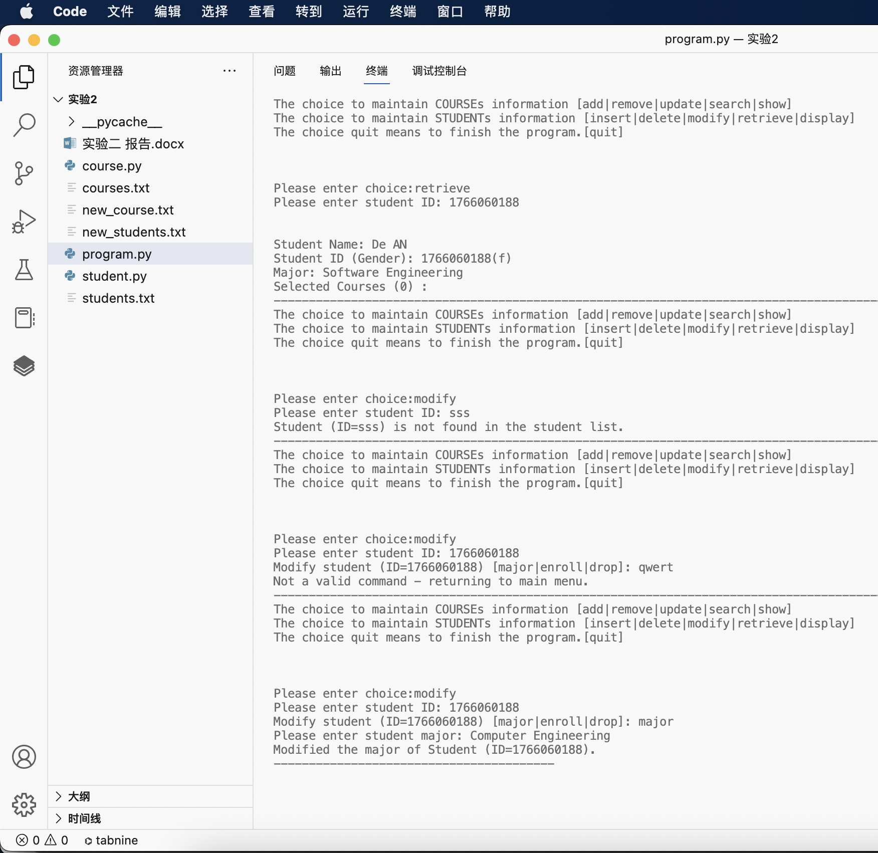

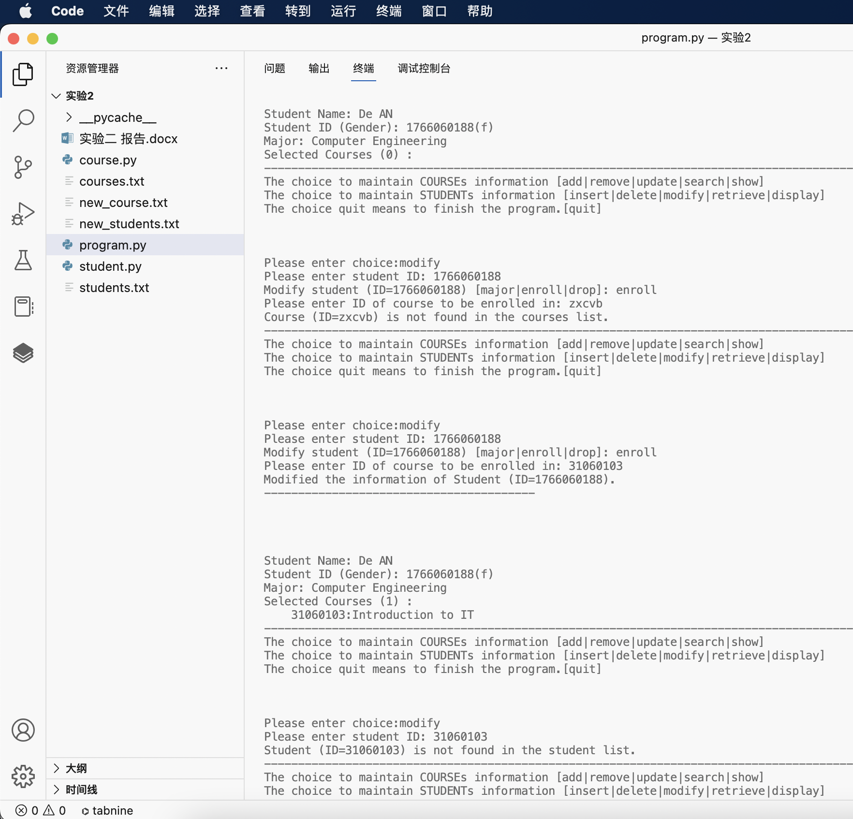

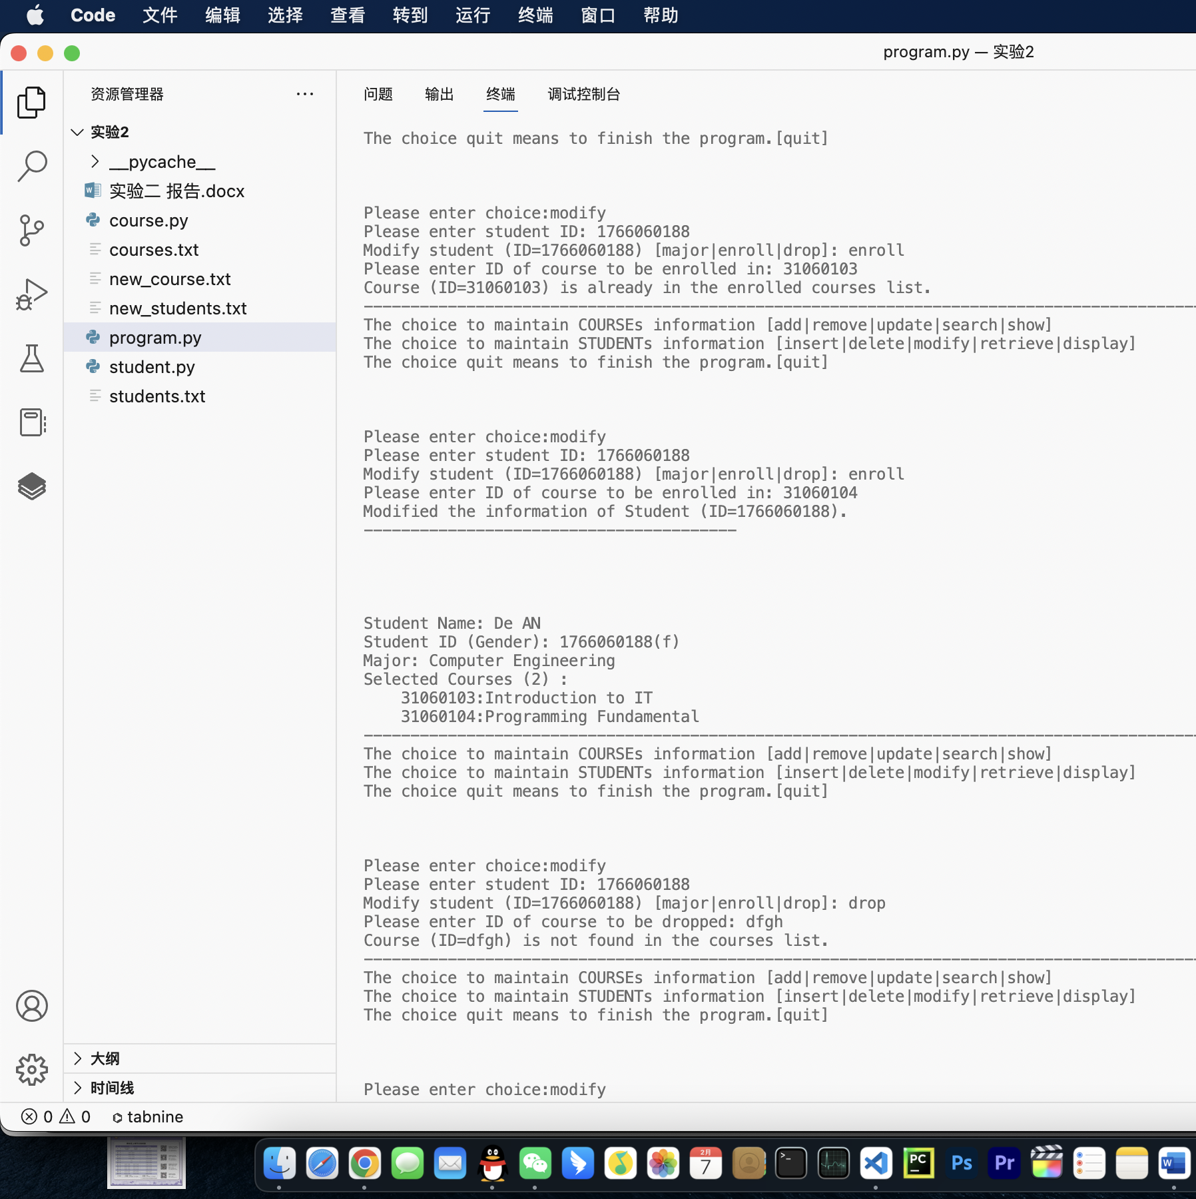

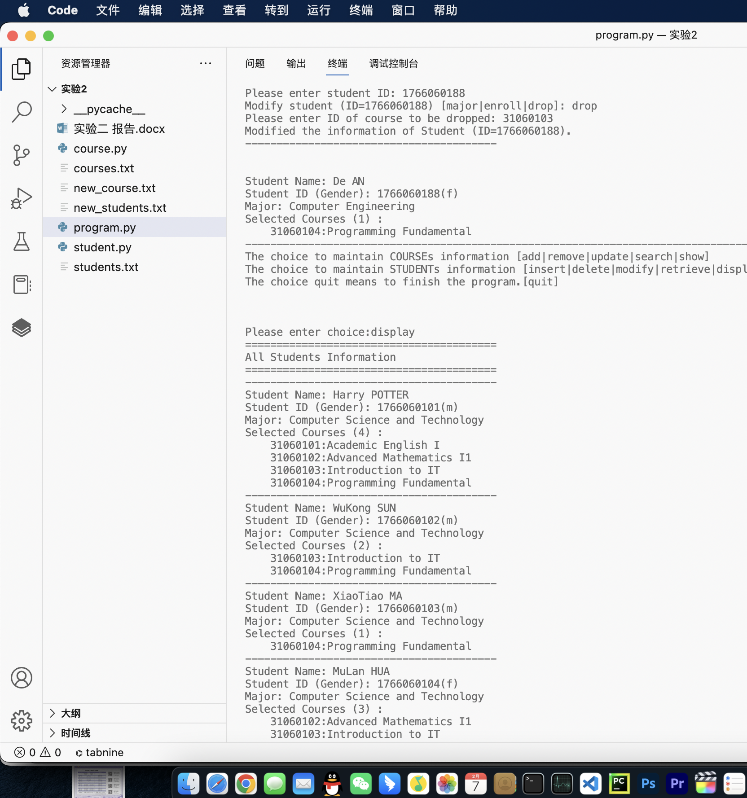

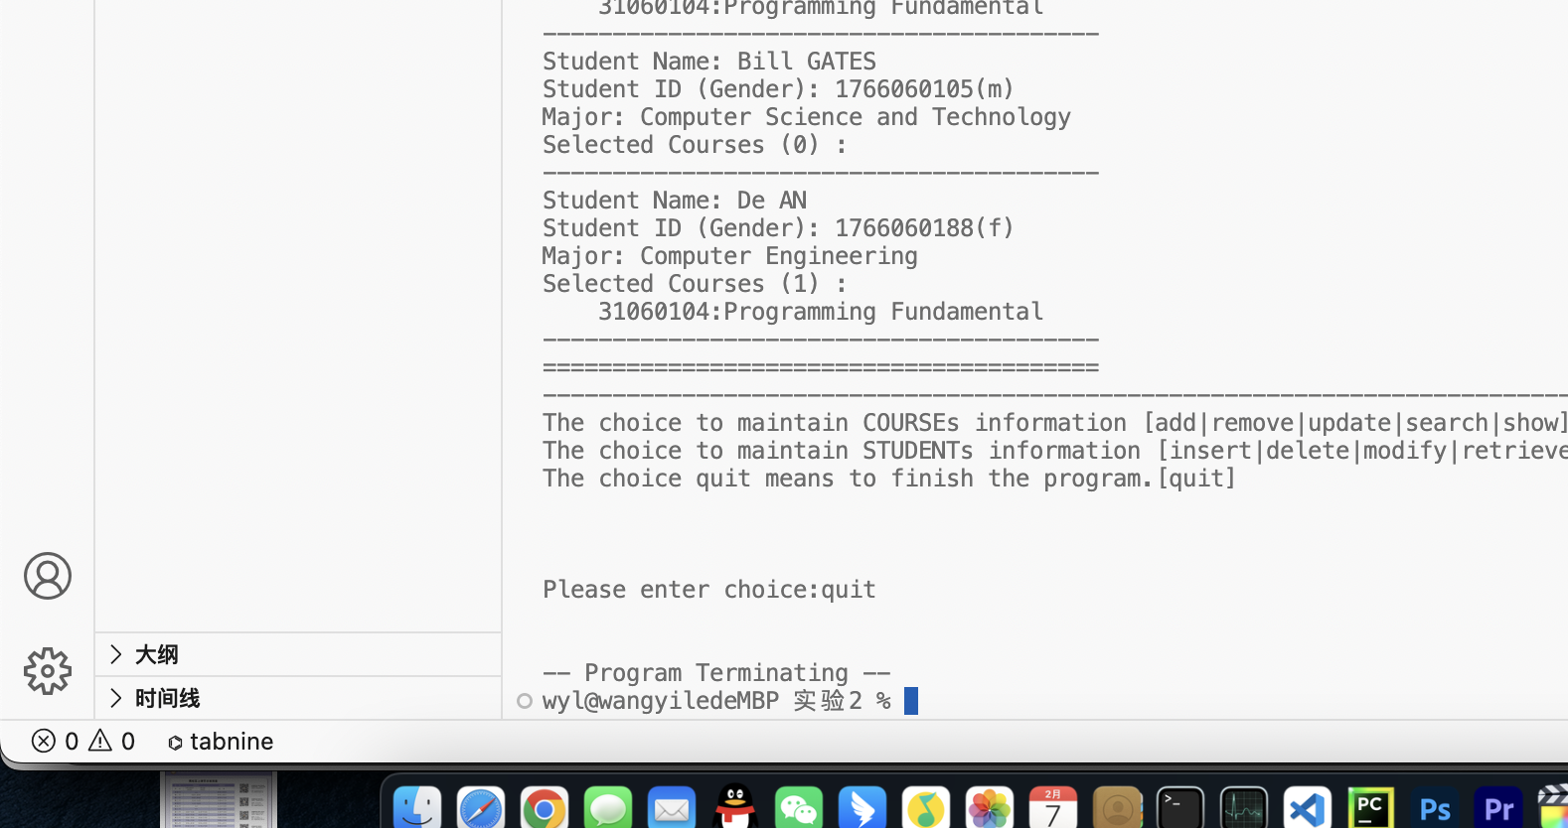

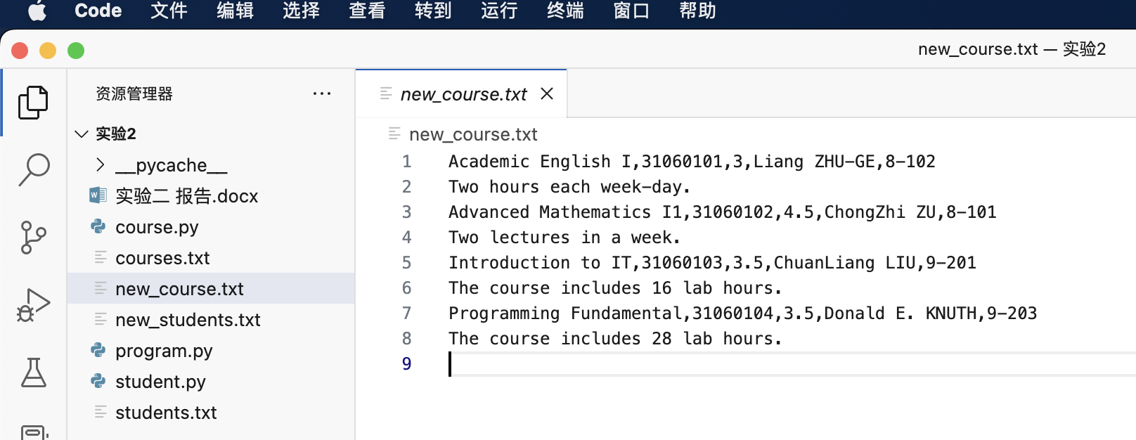

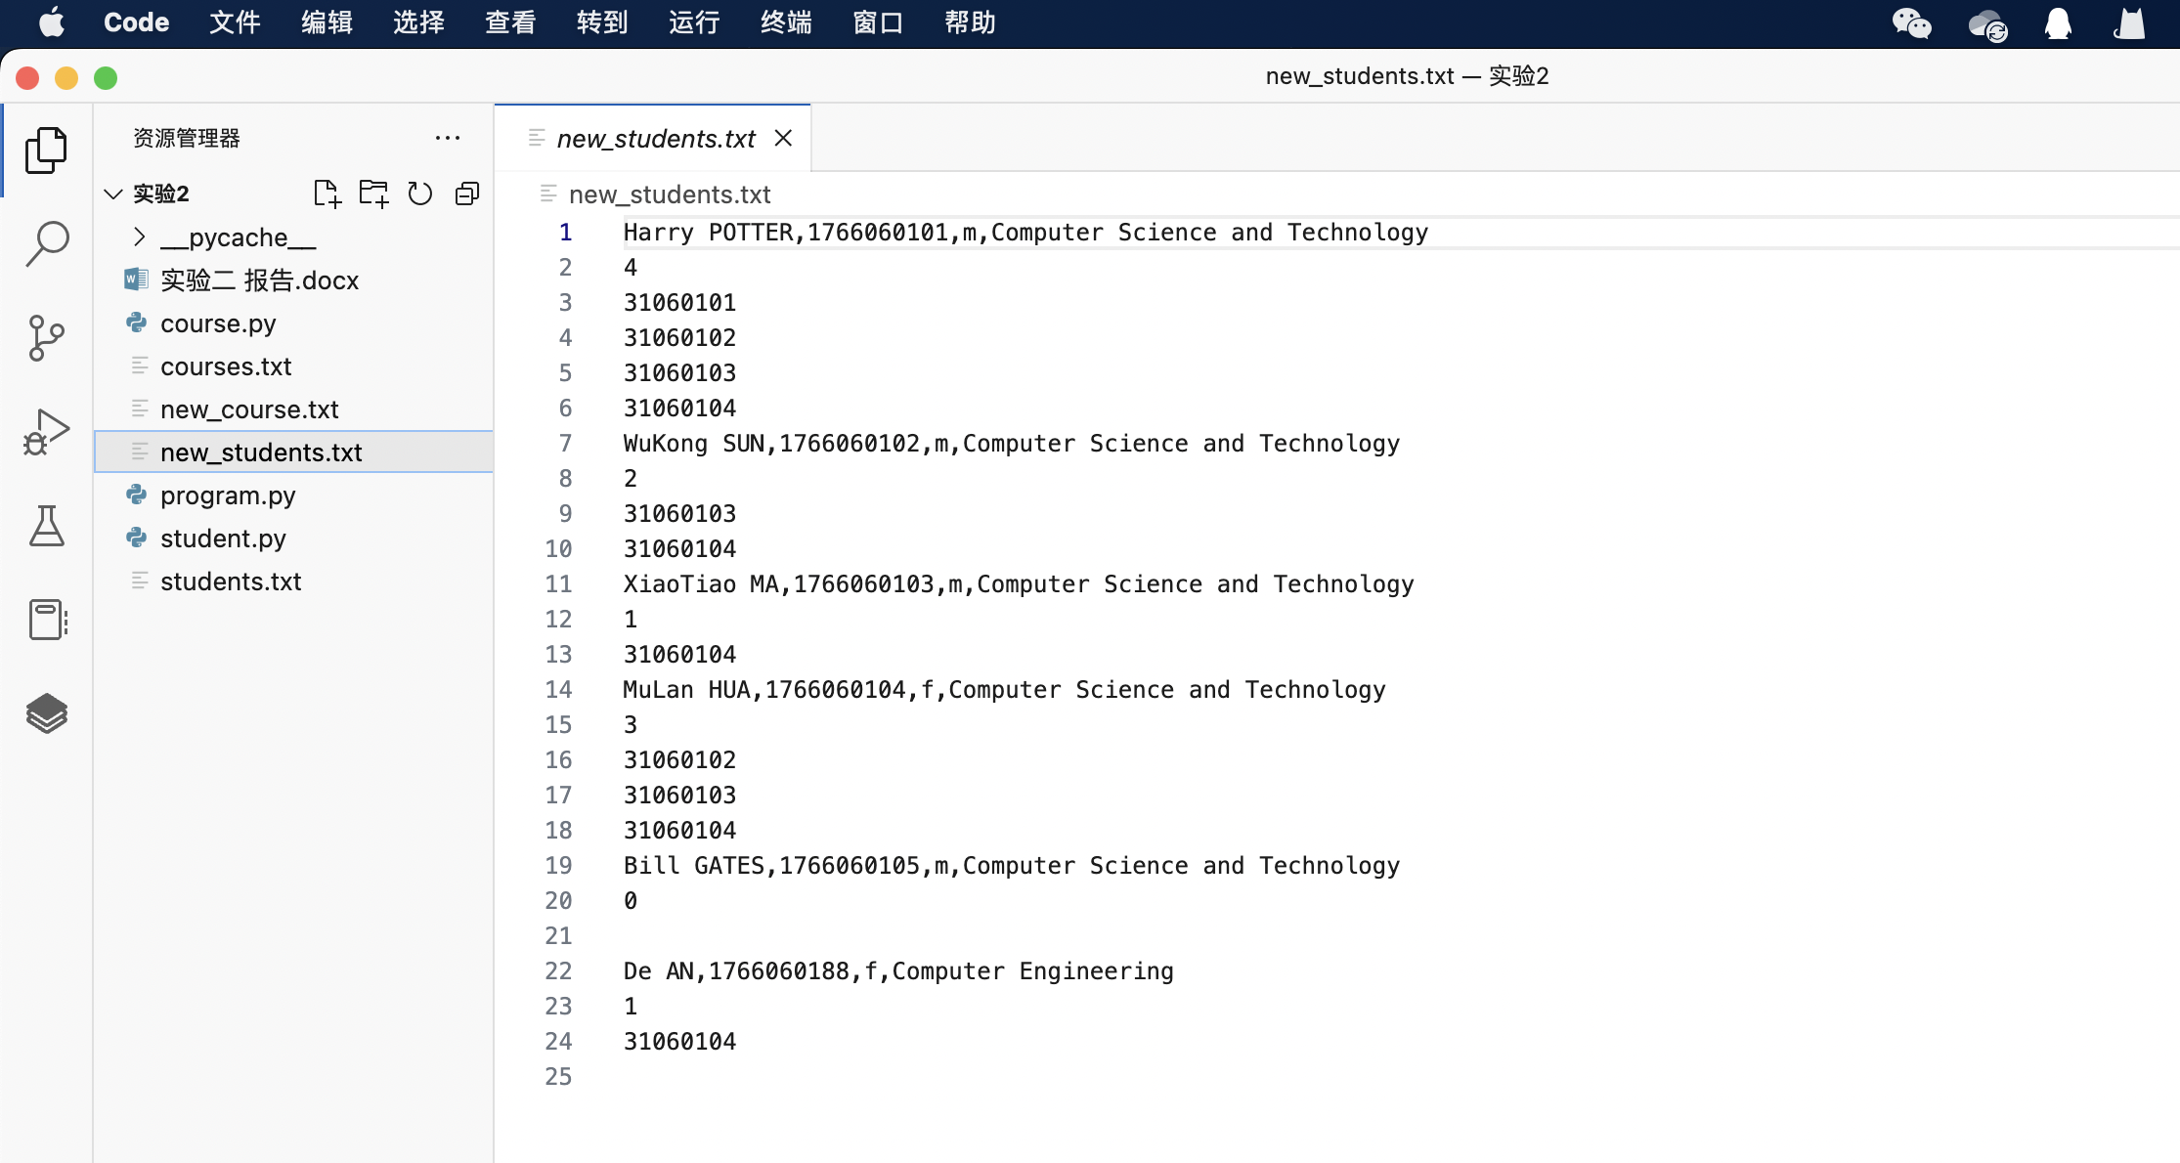

运行示例4

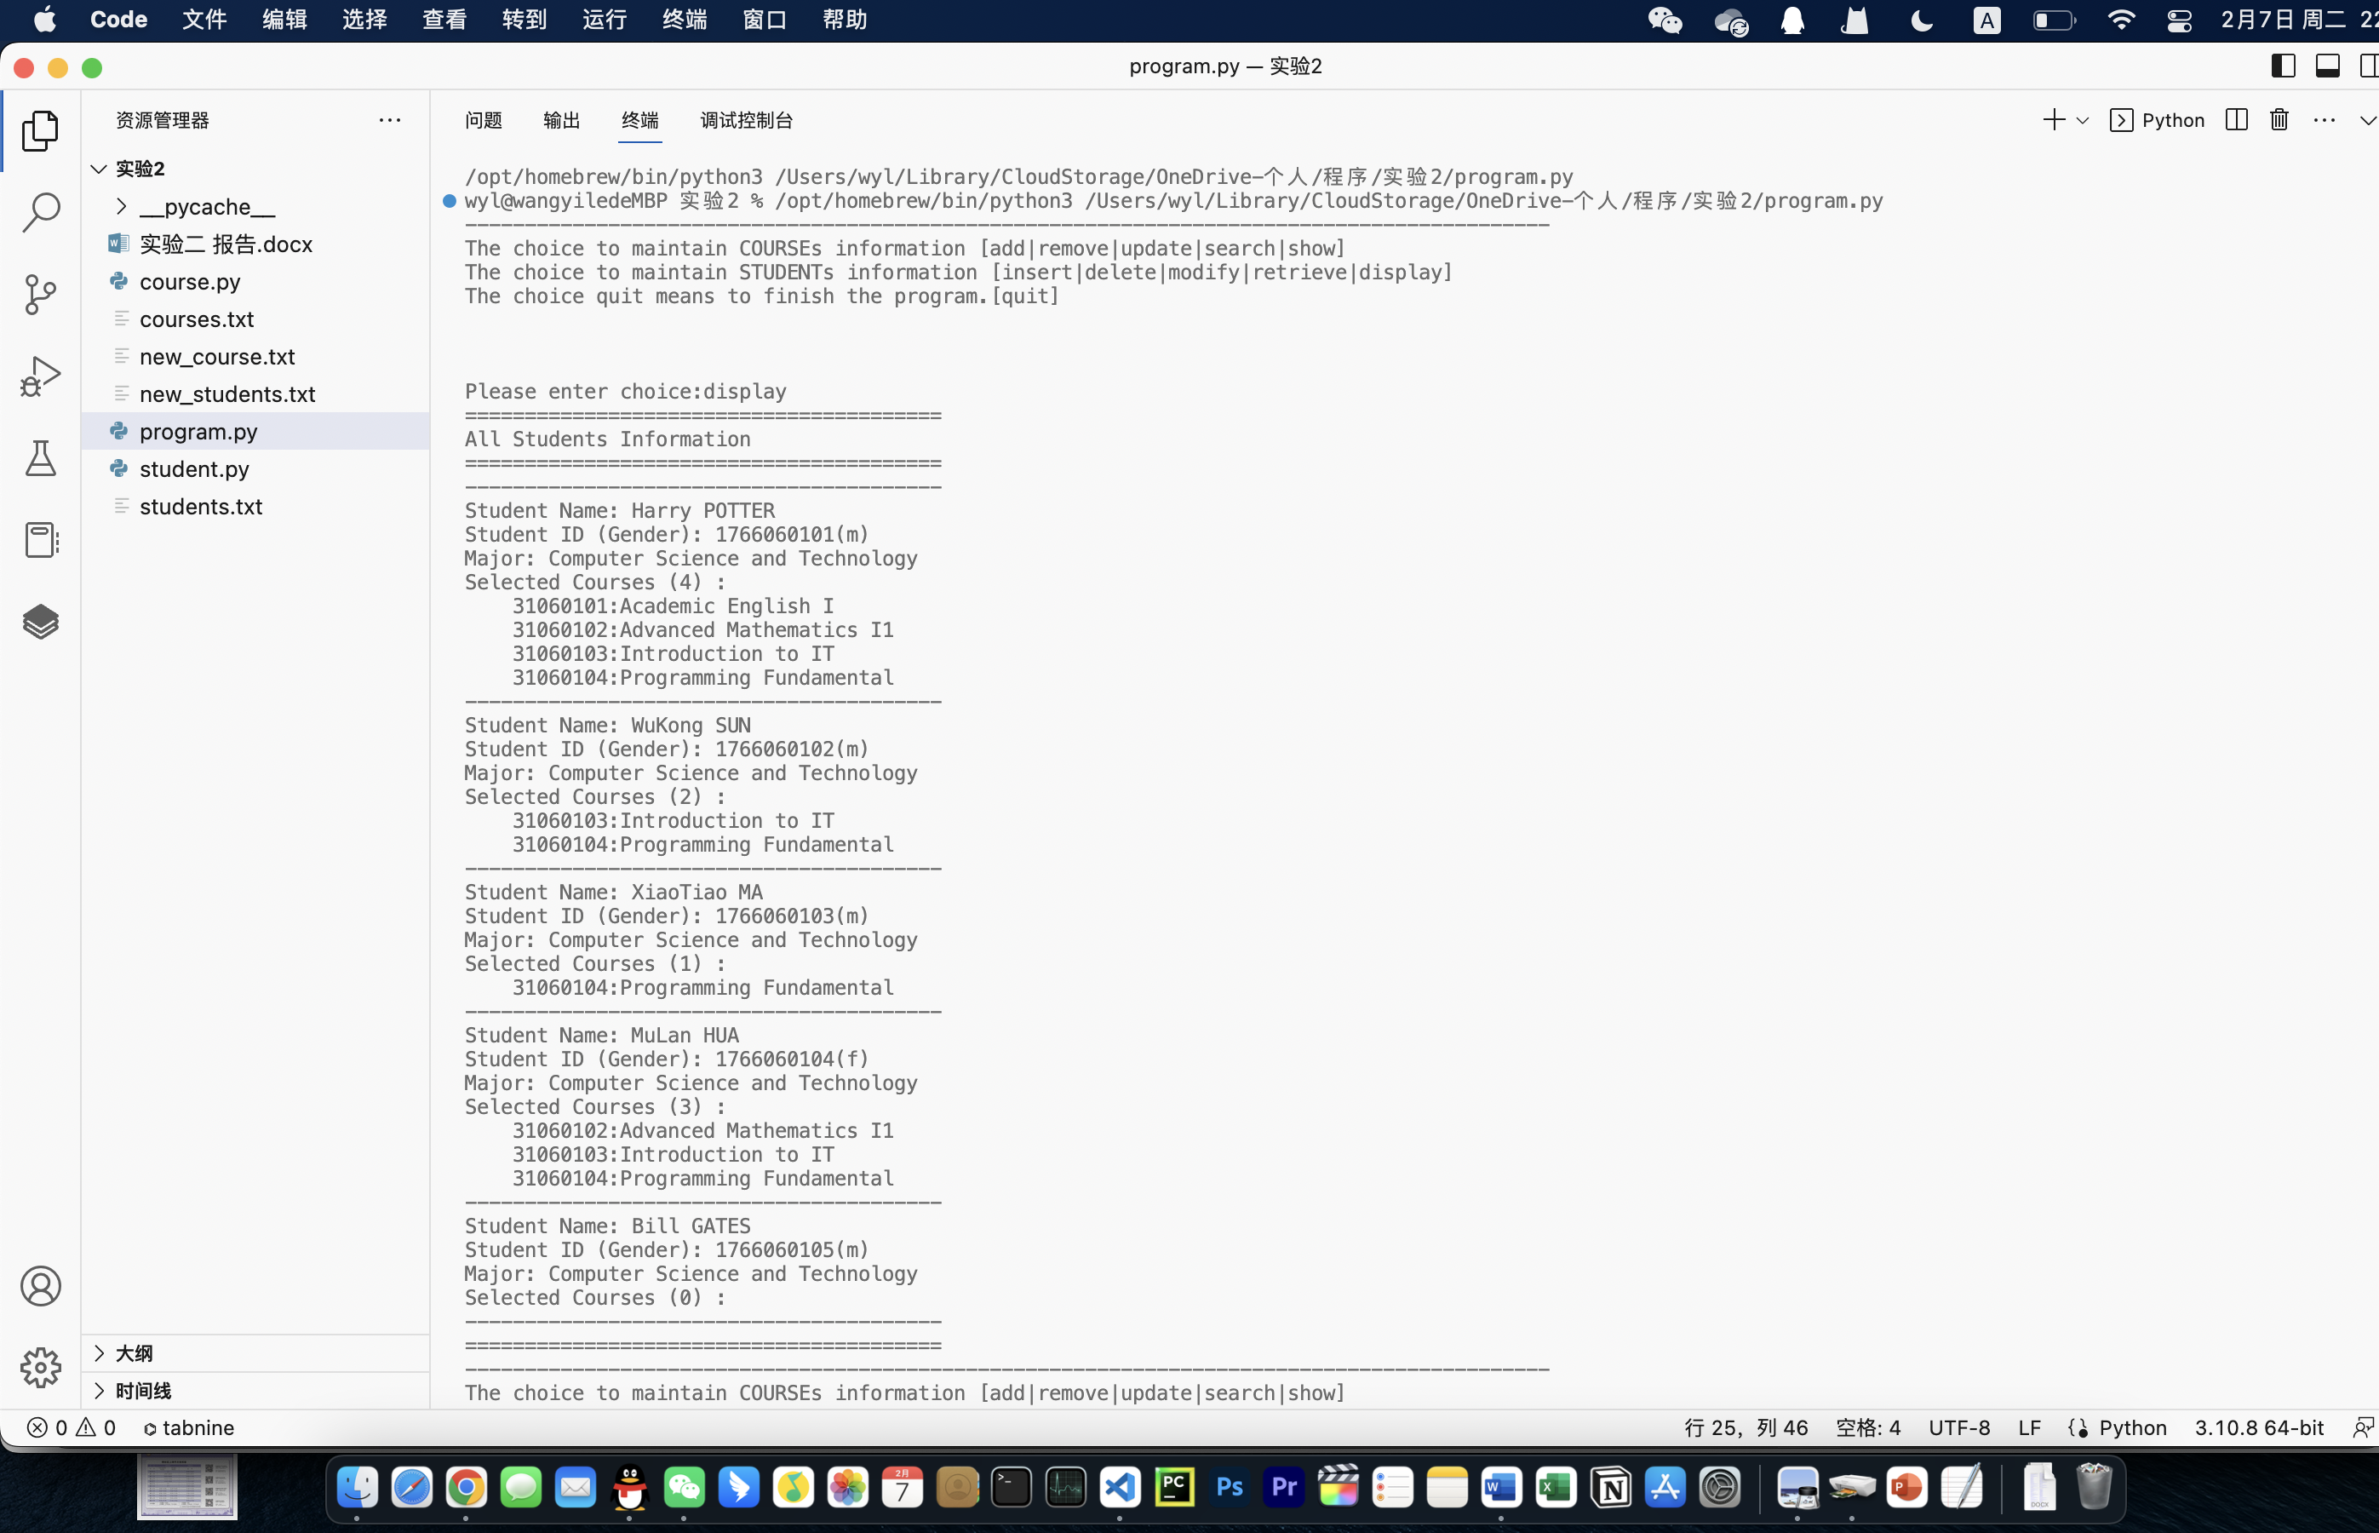

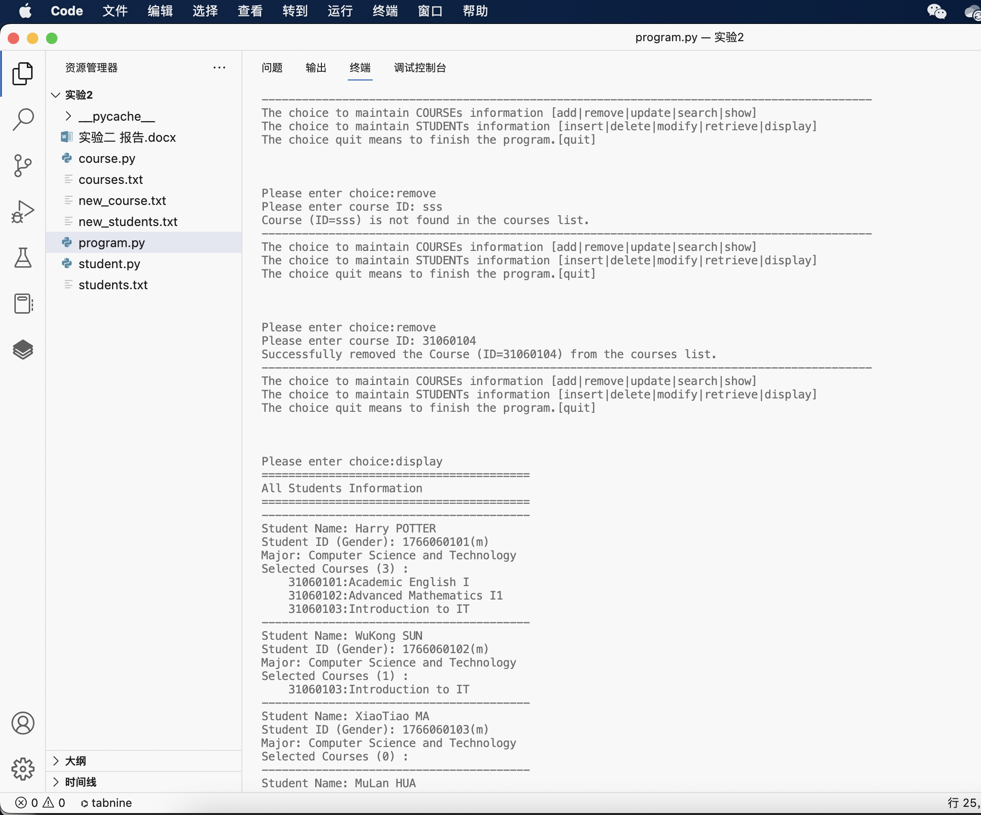

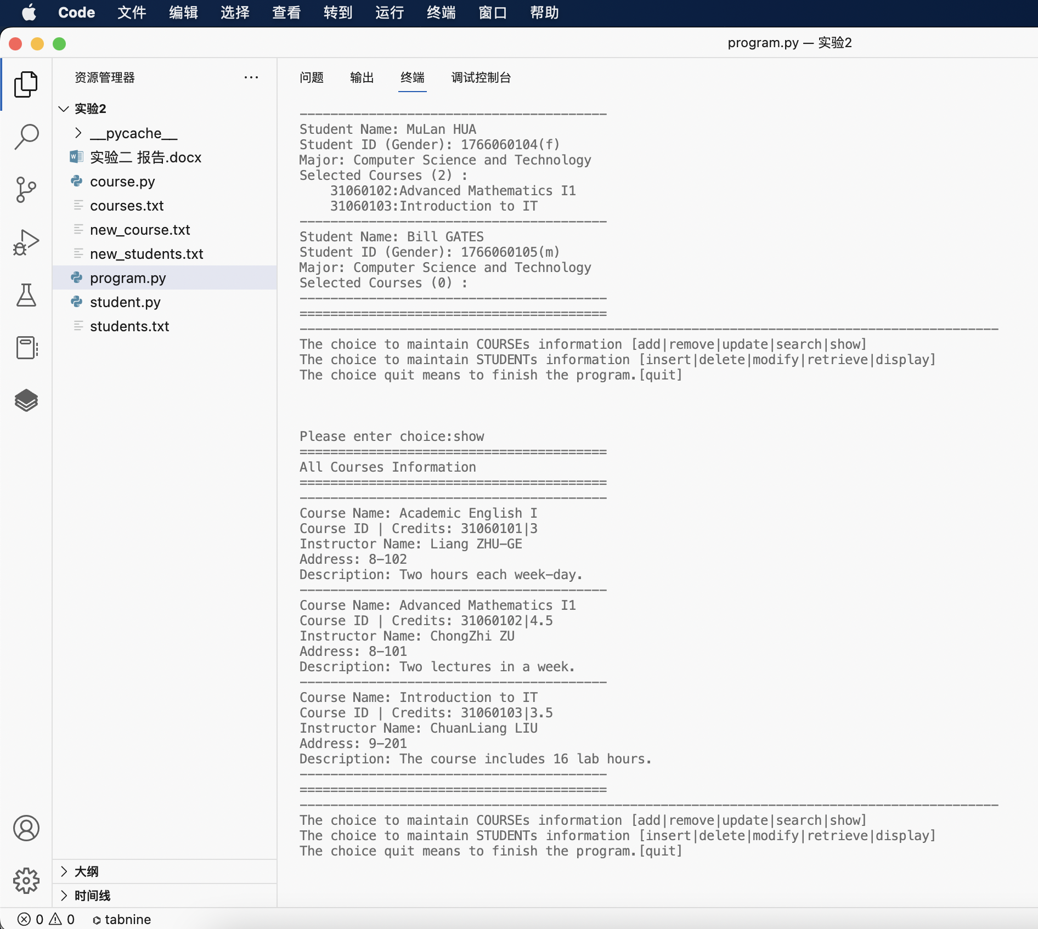

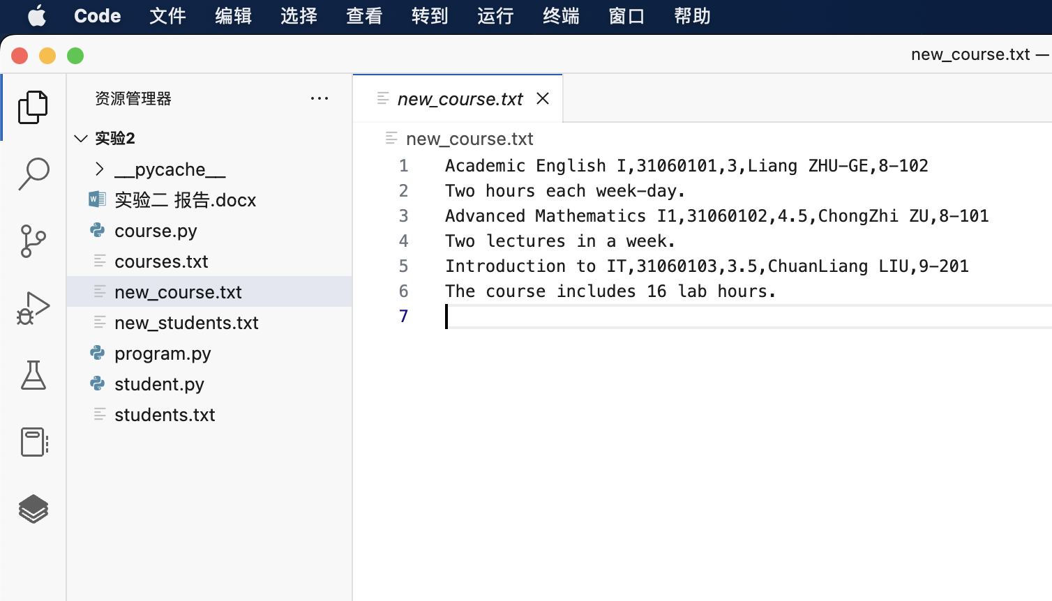

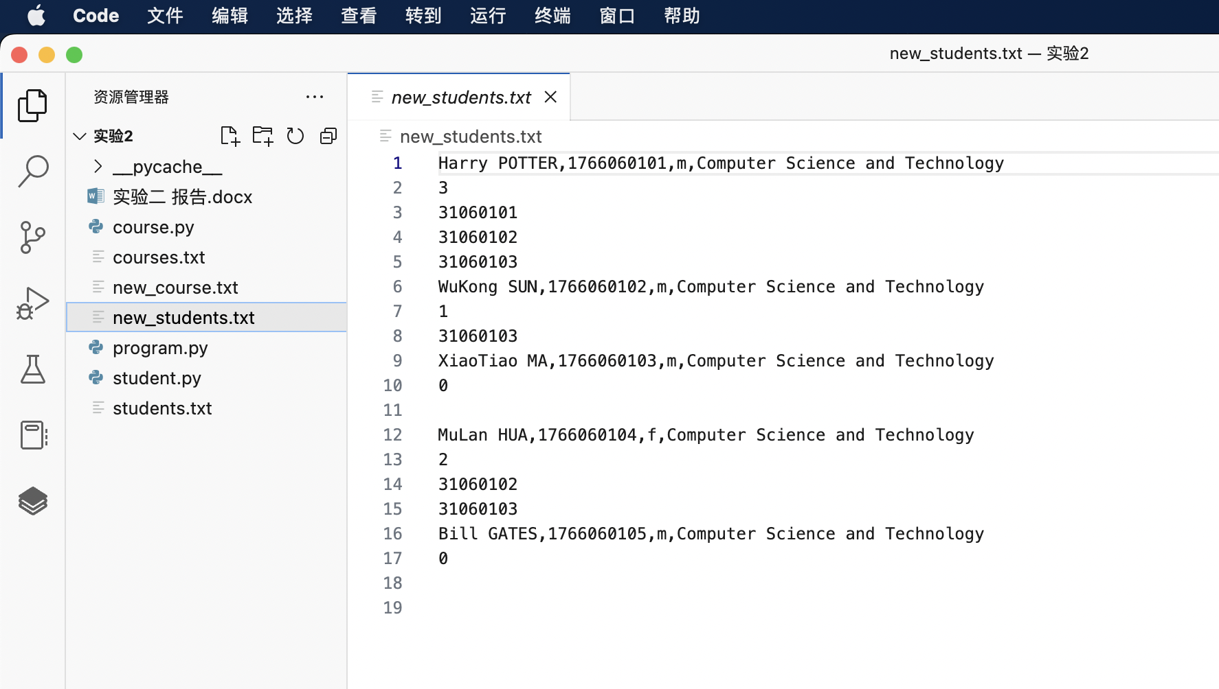

运行示例5

